Lab – Configuring Per-Interface Inter-VLAN Routing

1. Topology

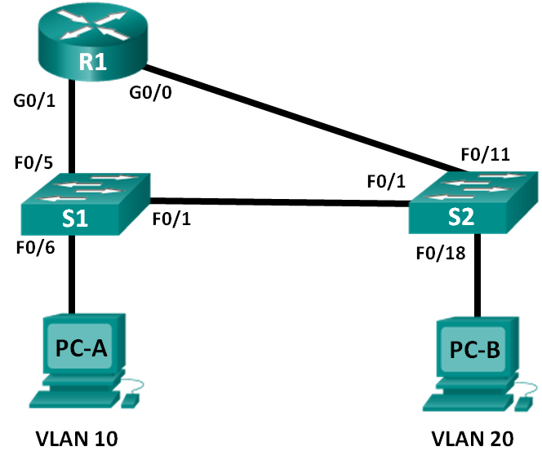

1. Addressing Table

|  |  |  |  |  |
| --- | --- | --- | --- | --- |
| Device | Interface | IP Address | Subnet Mask | Default Gateway |
| R1 | G0/0 | 192.168.20.1 | 255.255.255.0 | N/A |
|  | G0/1 | 192.168.10.1 | 255.255.255.0 | N/A |
| S1 | VLAN 10 | 192.168.10.11 | 255.255.255.0 | 192.168.10.1 |
| S2 | VLAN 10 | 192.168.10.12 | 255.255.255.0 | 192.168.10.1 |
| PC-A | NIC | 192.168.10.3 | 255.255.255.0 | 192.168.10.1 |
| PC-B | NIC | 192.168.20.3 | 255.255.255.0 | 192.168.20.1 |

1. Objectives

Part 1: Build the Network and Configure Basic Device Settings

Part 2: Configure Switches with VLANs and Trunking

Part 3: Verify Trunking, VLANs, Routing, and Connectivity

1. Background / Scenario

Legacy inter-VLAN routing is seldom used in today’s networks; however, it is helpful to configure and understand this type of routing before moving on to router-on-a-stick (trunk-based) inter-VLAN routing or configuring Layer-3 switching. Also, you may encounter per-interface inter-VLAN routing in organizations with very small networks. One of the benefits of legacy inter-VLAN routing is ease of configuration.

In this lab, you will set up one router with two switches attached via the router Gigabit Ethernet interfaces. Two separate VLANs will be configured on the switches, and you will set up routing between the VLANs.

**Note**: This lab provides minimal assistance with the actual commands necessary to configure the router and switches. The required switch VLAN configuration commands are provided in Appendix A of this lab. Test your knowledge by trying to configure the devices without referring to the appendix.

**Note**: The routers used with CCNA hands-on labs are Cisco 1941 Integrated Services Routers (ISRs) with Cisco IOS, Release 15.2(4)M3 (universalk9 image). The switches used are Cisco Catalyst 2960s with Cisco IOS, Release 15.0(2) (lanbasek9 image). Other routers, switches and Cisco IOS versions can be used. Depending on the model and Cisco IOS version, the commands available and output produced might vary from what is shown in the labs. Refer to the Router Interface Summary Table at the end of this lab for the correct interface identifiers.

**Note**: Make sure that the routers and switches have been erased and have no startup configurations. If you are unsure, contact your instructor.

1. Required Resources

* 1 Router (Cisco 1941 with Cisco IOS Release 15.2(4)M3 universal image or comparable)
* 2 Switches (Cisco 2960 with Cisco IOS Release 15.0(2) lanbasek9 image or comparable)
* 2 PCs (Windows 7, Vista, or XP with terminal emulation program, such as Tera Term)
* Console cables to configure the Cisco IOS devices via the console ports
* Ethernet cables as shown in the topology

1. Build the Network and Configure Basic Device Settings

In Part 1, you will set up the network topology and clear any configurations, if necessary.

* 1. Cable the network as shown in the topology.
  2. Initialize and reload the router and switches.
  3. Configure basic settings for R1.
     1. Disable DNS lookup.
     2. Assign the device name.
     3. Assign **class** as the privileged EXEC mode encrypted password.
     4. Assign **cisco** as the console and vty line password and enable login.
     5. Configure addressing on G0/0 and G0/1 and enable both interfaces.
  4. Configure basic settings on S1 and S2.
     1. Disable DNS lookup.
     2. Assign the device name.
     3. Assign **class** as the privileged EXEC mode encrypted password.
     4. Assign **cisco** as the console and vty line password and enable login.
  5. Configure basic settings on PC-A and PC-B.

Configure PC-A and PC-B with IP addresses and a default gateway address according to the Addressing Table.

1. Configure Switches with VLANs and Trunking

In Part 2, you will configure the switches with VLANs and trunking.

* 1. Configure VLANs on S1.
     1. On S1, create VLAN 10. Assign **Student** as the VLAN name.
     2. Create VLAN 20. Assign **Faculty-Admin** as the VLAN name.
     3. Configure F0/1 as a trunk port.
     4. Assign ports F0/5 and F0/6 to VLAN 10 and configure both F0/5 and F0/6 as access ports.
     5. Assign an IP address to VLAN 10 and enable it. Refer to the Addressing Table.
     6. Configure the default gateway according to the Addressing Table.
  2. Configure VLANs on S2.
     1. On S2, create VLAN 10. Assign **Student** as the VLAN name.
     2. Create VLAN 20. Assign **Faculty-Admin** as the VLAN name.
     3. Configure F0/1 as a trunk port.
     4. Assign ports F0/11 and F0/18 to VLAN 20 and configure both F0/11 and F0/18 as access ports.
     5. Assign an IP address to VLAN 10 and enable it. Refer to the Addressing Table.
     6. Configure the default gateway according to the Addressing Table.

1. Verify Trunking, VLANs, Routing, and Connectivity
   1. Verify the R1 routing table.
      1. On R1, issue the **show ip route** command. What routes are listed on R1?

____________________________________________________________________________________

* + 1. On both S1 and S2, issue the **show interface trunk** command. Is the F0/1 port on both switches set to trunk? _____________
    2. Issue a **show vlan brief** command on both S1 and S2. Verify that VLANs 10 and 20 are active and that the proper ports on the switches are in the correct VLANs. Why is F0/1 not listed in any of the active VLANs?

____________________________________________________________________________________

* + 1. Ping from PC-A in VLAN 10 to PC-B in VLAN 20. If Inter-VLAN routing is functioning correctly, the pings between the 192.168.10.0 network and the 192.168.20.0 should be successful.

**Note**: It may be necessary to disable the PC firewall to ping between PCs.

* + 1. Verify connectivity between devices. You should be able to ping between all devices. Troubleshoot if you are not successful.

1. Reflection

What is an advantage of using legacy inter-VLAN routing?

_______________________________________________________________________________________

_______________________________________________________________________________________

_______________________________________________________________________________________

1. Router Interface Summary Table

|  |  |  |  |  |
| --- | --- | --- | --- | --- |
| Router Interface Summary | | | | |
| Router Model | Ethernet Interface #1 | Ethernet Interface #2 | Serial Interface #1 | Serial Interface #2 |
| 1800 | Fast Ethernet 0/0 (F0/0) | Fast Ethernet 0/1 (F0/1) | Serial 0/0/0 (S0/0/0) | Serial 0/0/1 (S0/0/1) |
| 1900 | Gigabit Ethernet 0/0 (G0/0) | Gigabit Ethernet 0/1 (G0/1) | Serial 0/0/0 (S0/0/0) | Serial 0/0/1 (S0/0/1) |
| 2801 | Fast Ethernet 0/0 (F0/0) | Fast Ethernet 0/1 (F0/1) | Serial 0/1/0 (S0/1/0) | Serial 0/1/1 (S0/1/1) |
| 2811 | Fast Ethernet 0/0 (F0/0) | Fast Ethernet 0/1 (F0/1) | Serial 0/0/0 (S0/0/0) | Serial 0/0/1 (S0/0/1) |
| 2900 | Gigabit Ethernet 0/0 (G0/0) | Gigabit Ethernet 0/1 (G0/1) | Serial 0/0/0 (S0/0/0) | Serial 0/0/1 (S0/0/1) |
| **Note**: To find out how the router is configured, look at the interfaces to identify the type of router and how many interfaces the router has. There is no way to effectively list all the combinations of configurations for each router class. This table includes identifiers for the possible combinations of Ethernet and Serial interfaces in the device. The table does not include any other type of interface, even though a specific router may contain one. An example of this might be an ISDN BRI interface. The string in parenthesis is the legal abbreviation that can be used in Cisco IOS commands to represent the interface. | | | | |

1. Appendix A: Configuration Commands
2. Switch S1

S1(config)# **vlan 10**

S1(config-vlan)# **name Student**

S1(config-vlan)# **exit**

S1(config)# **vlan 20**

S1(config-vlan)# **name Faculty-Admin**

S1(config-vlan)# **exit**

S1(config)# **interface f0/1**

S1(config-if)# **switchport mode trunk**

S1(config-if)# **interface range f0/5 – 6**

S1(config-if-range)# **switchport mode access**

S1(config-if-range)# **switchport access vlan 10**

S1(config-if-range)# **interface vlan 10**

S1(config-if)# **ip address 192.168.10.11 255.255.255.0**

S1(config-if)# **no shut**

S1(config-if)# **exit**

S1(config)# **ip default-gateway 192.168.10.1**

1. Switch S2

S2(config)# **vlan 10**

S2(config-vlan)# **name Student**

S2(config-vlan)# **exit**

S2(config)# **vlan 20**

S2(config-vlan)# **name Faculty-Admin**

S2(config-vlan)# **exit**

S2(config)# **interface f0/1**

S2(config-if)# **switchport mode trunk**

S2(config-if)# **interface f0/11**

S2(config-if)# **switchport mode access**

S2(config-if)# **switchport access vlan 20**

S2(config-if)# **interface f0/18**

S2(config-if)# **switchport mode access**

S2(config-if)# **switchport access vlan 20**

S2(config-if-range)# **interface vlan 10**

S2(config-if)#**ip address 192.168.10.12 255.255.255.0**

S2(config-if)# **no shut**

S2(config-if)# **exit**

S2(config)# **ip default-gateway 192.168.10.1**